
Development Request
Aria Systems
Amend CP 200488 – Carton Processing for Memo

Program Add-in Template Description

Program Add-in Template

Program Add-in Header
Product: | Aria27
Module: | PO
Customer name: | Nik Nak Clothing
Installed Modules: | AL, AR, IC, PO, RM, SO , SR, SM, AP,GL
Parameters setting: | Multi-Currency, Multi-Warehouse, Extended sizes –Yes  Style code structure 12-3-3  Characters for size scale code = 2

Details Section
Add-in Name :
Add-in Objective : The carton processing needs to be modified so that it is driven by carton not by units. The CP will be amended for Nik Nak. However, the original customer Memo will use this new processing also. Therefore a separate set of CP’s do not need to be created

Description ( Processing ) :

Currently the carton data is entered when the PO receipt is processed. This needs to be amended so that the carton details are entered when the Shipment is processed.

The user will process the Shipment header data and then click on Details, then click on Options and select an option ‘ Carton Details’

The carton screen will appear prompting the user to select a PO number. Note: each Purchase order can have more than one style and multiple styles can be assigned to a carton so when the PO number is selected all the styles on the PO will appear and the user can ignore any lines not required.

When the user selects the first PO , the styles/colours on the selected PO are then listed

The carton screen will need to be amended as follows:-

* PO number selected at the top of the screen.
* Warehouse code at top of screen
* Total per Ctn field which should be updated automatically as the quantities are entered on the screen
* Show the styles selected down the left of the screen.
* For extended sizes, all sizes for the same style/colour to be shown on a scrolling line rather than a separate line.
* Print the colour description at the bottom of the screen

Carton Details

PO 060011 Warehouse MAIN Total per Ctn 50 No of cartons 100
Weight 0.00 Length 0 Width 0 Depth 0

Style/Colour Qty1 Qty2 Qty3 Qty4 Qty5 Qty6 Qty7 Qty8
123456-001 1 2 2 2 2 2 2 2
123456-005 2 2 1 2 1 1 2 1
124785-001 1 2 2 2 1 1 1 1
124785-008 1 2 1 2 1 2 1 2

Style/Colour 16 18 20 22 24 26 28 30 (for more sizes)
123456-001 1 2 2 2 2 2 2 2
Burgundy Red

The items in red on the screen display on the previous page indicate changes to be made to the layout of the current carton input screen available in PO receipts

When the user has entered the carton details for the first PO and styles and clicked on OK, the user will then be returned to the carton summary screen (Carton Types)

If the user clicks on New on this screen, the user is again prompted to select a PO , which may be a different PO/styles or the same PO/styles as previously selected with a different carton breakdown.

If the user elects to modify a specific carton line from the Carton Types screen, the user should be able to edit the ‘No of Cartons’ field as well as the carton breakdown.

When the user closes the carton types screen having specified all the carton details for the shipment, the standard shipment details screen containing the PO’s styles/colours and size total quantities (POSLN) should be updated from the carton data entered ie . no of cartons * units per carton by style/colour/size for each carton type. The user can return to the ‘Carton Details’ screen and amend or add as necessary either before or after saving the shipment. The system will load the Carton Types screen and the user can do New or select a specific carton line to remove or modify. On saving the PO a new file SHPCRTMF should be updated. This file will contain the same data and fields as POCRTNMF except for the field PIKTKT which is not required at this stage.

Receive PO’s

1. Receive by Shipment

When the user selects to receive by shipment, the user will key in the shipment number. Then the user will click on Options and an Option will be available, ‘Receive Cartons’

When the use clicks on this option, the carton types screen will be displayed listing the carton types which have been entered on the shipment in the new file ‘SHPCRTNMF’

The user can then click on a carton line and click on ‘Modify’.
The carton details screen (with the same layout as that on the shipment) will be displayed and the user should be able to change the displayed warehouse, change the number of cartons and the carton breakdown by style/colour size.
On the Carton types screen the user should also be allowed to remove carton types or add New carton types

When the user closes the Carton Types screen, the system should re-calculate from the carton information entered, the total quantities by PO/Style/Colour/Size to update to Stock 1st Quality.

On saving the Shipment receipt, the POCRTNMF file should be updated with the carton details as entered on the receipt.

If the user saves the shipment without specifying carton details the user should later be able to return to the shipment and create the carton data. This should be allowed provided no part of the shipment has been received

2. Receive by PO

If there is no shipment for the PO, the user will Receive by PO. When the user keys in the PO to receive and requests to receive Automatically, the user will then click on options ‘Receive Cartons’. The carton types screen will be displayed and the user can then click on New. The carton details screen will then be displayed with the PO number as entered already shown with the styles/colours listed. The warehouse as entered on POSHDR will also be shown and the user can overwrite.
The user will then enter the number of cartons, carton details (weight, etc) and the carton quantities for each styles/size/colour
When the user has clicked OK the user will be able to click New again on the Carton Types screen to specify further carton breakdowns for the same PO.
Closing the carton types screen will update the stock 1st quality receipts for the PO by style/colour/size.
Saving the receipt will update as per the shipment receipt

Allocation By Order

Amend CP C200489 as follows:-

The user keys in the sales order number to allocate, clicks Option Generate Picking Ticket.
A new option titled ‘Pick Cartons’ should be added to the options list.

When the user clicks this Option, the allocation by cartons screen appears.

Note: Multiple styles can be contained in one carton

This screen will be the same as now except a field should be added to show the quantity in each carton type
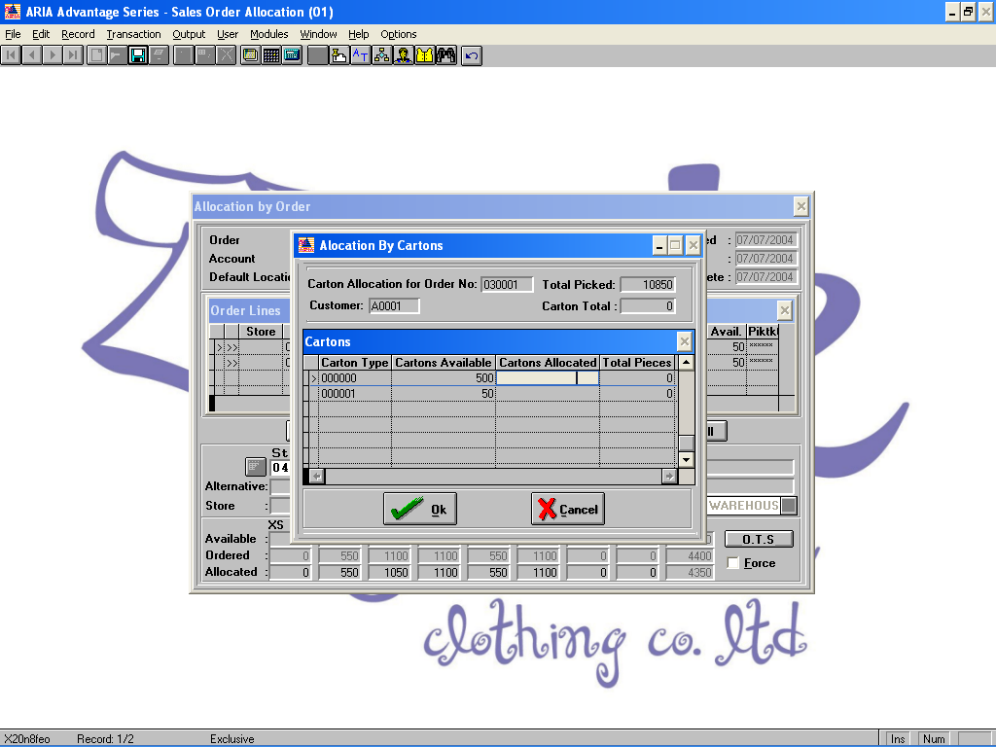

Add a new field for Carton Qty which will show the quantity in a carton for each carton type as you click on the carton type.

When the user keys in the cartons allocated and then clicks OK, the quantities on the Allocation by order screen are then picked and the picking ticket number is assigned.

The user can at any time return to Options - Pick Cartons and amend the cartons allocated as required and the amended totals will be updated to the picked lines

Amend Packing List program

When the user has picked the order, the user will then go to Packing List – Manual to generate a Packing List for the pick ticket

When the user keys the picking ticket and keys in the header information for the packing list, the user will then click on detail. The user will not Select all and Apply at this point.
A new option should be added to the Option list titled. ‘Generate Cartons’. When the user clicks on this option, the system will generate the carton breakdowns based on the carton types and number of cartons selected when generating the picking ticket
This will then update the data in the Detail information and Carton Information screens and update to PACK_LIN.dbf

